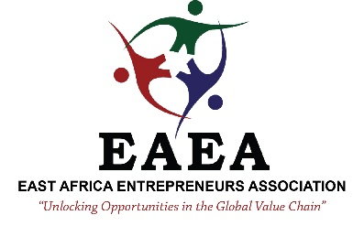
CONSENT AND TERMS OF USE TO PARTICIPATE IN BEAUTY ISTANBUL (MAY 8-10, 2025) & KONYA AGRICULTURAL SHOW (APRIL 8-12, 2025)

Please read carefully, fill and sign this consent form if you agree with terms and conditions stated for participating in this organized by East Africa Entrepreneurs Association (EAEA) and its partners. Send back to bds@eaentrepreneurs.org / info@eaentrepreneurs.org.
Name of Show/Event:

Your Company Name:
Position:
First Name Surname

Date of birth : - Place of birth: - Country :
Passport No: - Passport Issue on: – Passport Expiry on:
Address: |  | City:
Phone (Office): Mobile :
E-mail: Website :
Have you participated in any show/expo: | Social Media:
Interests / Expectations/ Reason(s) for your participation:

Brief Description of your Company: Current Activities/Projects:

Please attach the following documents: Passport, Proof of EAEA Membership, Company documents

CONSENT
- I ……………………………………………… ….. do hereby consent to pay 300 US Dollars for Registration fees, Invitation Letter, and administrative fees for handling the visa application and I have paid this money well knowing that in the event the embassy declines to grant a visa for my application, I shall not claim refund of the same from East African Entrepreneurs Association.
- I have read this document completely. I understand that EAEA provides only administrative assistance in the submission of my application to Embassy of Turkey and that the service is provided according to the terms and conditions of EAEA.

SIGNATURE:………………………………………………….. DATE:…………………………………………………..

